IT3207:Cloud Computing

Name of the student: Aditya Santosh Nimbolkar Roll No. 64

Div: IT-B Batch: 3

Date of performance:16/01/2025

Experiment No.3

Find a procedure to transfer the files from one virtual machine to another virtual machine.

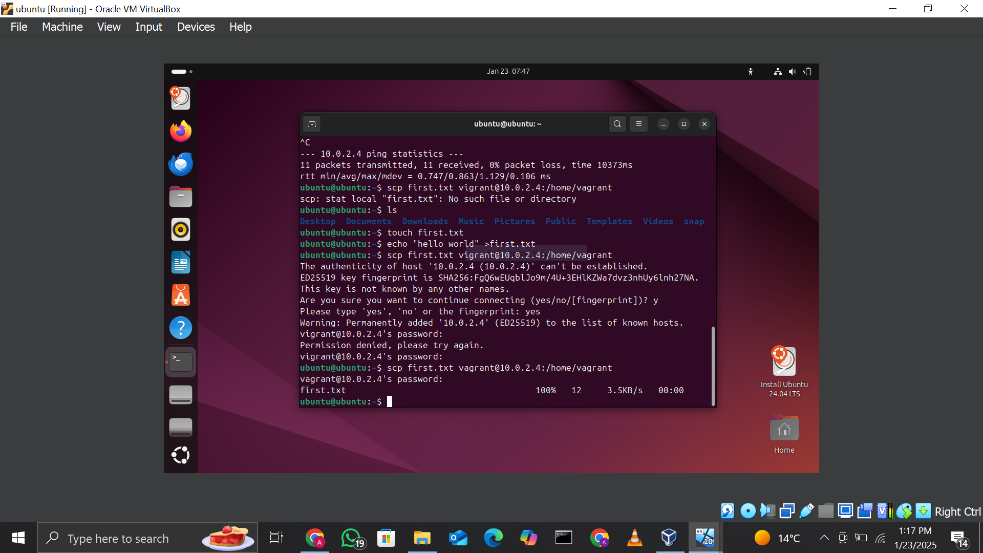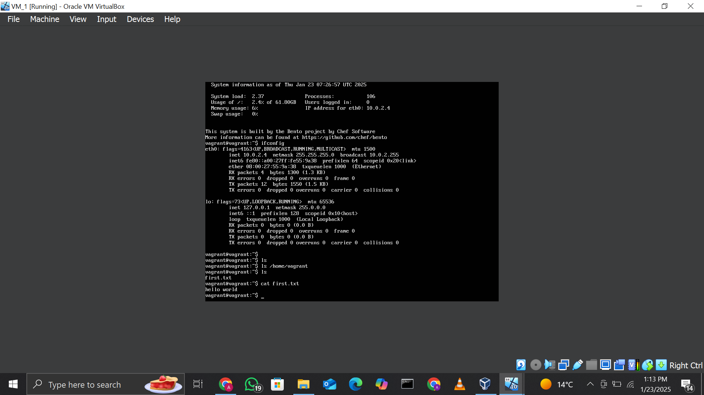

Commands Used:
- To check IP address on ubuntu1 and VM_1:
ifconfig
- To create a file on ubuntu1:
nano file1.txt
  - Add the content to the file and save it (Ctrl + O to save, Ctrl + X to exit).
- To transfer the file from ubuntu1 to VM_1 using SCP:
scp file1.txt vagrant@<VM_1_IP>:/home/vagrant
  - Replace <VM_1_IP> with the IP address of VM_1 (e.g., 10.0.2.5).
- To verify the file on VM_1:
ls /home/vagrant
cat /home/vagrant/file1.txt

Procedure:
- Set Up Virtual Machines:
  - Launch VirtualBox and create two virtual machines (ubuntu1 and VM_1) using Ubuntu VMDK images.
- Configure Networking:
  - Ensure both virtual machines are connected to the same NAT Network for communication.
- Find IP Addresses:
  - Start each virtual machine, open the terminal, and use ifconfig to find the IP address of each machine.
- Prepare a File on ubuntu1:
  - Create a text file (file1.txt) using a text editor (e.g., nano) and write some content into it.
- Transfer File Using SCP:
  - From the terminal in ubuntu1, use the scp command to securely copy the file to VM_1.
Syntax: scp <filename> <user>@<destination_IP>:<path>
Example: scp file1.txt vagrant@10.0.2.5:/home/vagrant
- Authenticate:
  - Enter the password for the destination VM user (vagrant) when prompted.
- Verify the File on VM_1:
  - Log in to VM_1, navigate to the specified directory (/home/vagrant), and use the ls and cat commands to ensure the file was successfully transferred.

